**20CS2016L – Database Systems Lab**

**URK22AI1048**

|  |  |
| --- | --- |
| **Ex no:** | **1B – Managing Tables using DML, DCL and TCL Commands** |
| **Date** | **19/12/2023** |

**AIM:**

The aim is to efficiently manage database tables using Data Control Language (DCL), Data Manipulation Language (DML), and Transaction Control Language (TCL) for secure data access, manipulation, and transaction consistency

# DESCRIPTION:

This involves granting and revoking user permissions (DCL), manipulating data through SELECT, INSERT, UPDATE, and DELETE operations (DML), and ensuring transactional integrity with COMMIT, ROLLBACK, and SAVEPOINT commands (TCL). The goal is to maintain a secure, organized, and reliable database system.

In this schema, we have four main tables: User, Event, Venue, and Ticket.

**User table:**

|  |  |
| --- | --- |
| **Column** | **Data Type** |
| UserID | NUMBER(10) |
| Name | VARCHAR2(255) |
| Email | VARCHAR2(255) |
| Password | VARCHAR2(255) |
| Phone | VARCHAR2(20) |

**Event table:**

|  |  |
| --- | --- |
| **Column** | **Data Type** |
| EventID | NUMBER(10) |
| Name | VARCHAR2(255) |
| Date | DATE |

|  |  |
| --- | --- |
| Time | VARCHAR |
| VenueID | NUMBER(10) (Foreign key) |
| Description | VARCHAR2(500) |

**Venue table:**

|  |  |
| --- | --- |
| **Column** | **Data Type** |
| VenueID | NUMBER(10) |
| Name | VARCHAR2(255) |
| Address | VARCHAR2(255) |
| City | VARCHAR2(255) |
| State | VARCHAR2(255) |
| Country | VARCHAR2(255) |

**Ticket table:**

|  |  |
| --- | --- |
| **Column** | **Data Type** |
| TicketID | NUMBER(10) |
| EventID | NUMBER(10) (Foreign key) |
| UserID | NUMBER(10) |
| SeatNumber | VARCHAR2(20) |
| Price | NUMBER(10, 2) |
| Status | VARCHAR2(50) |

# QUERIS AND OUTPUT SCREENSHOT:

1. Insert a new user into the “User”; table.

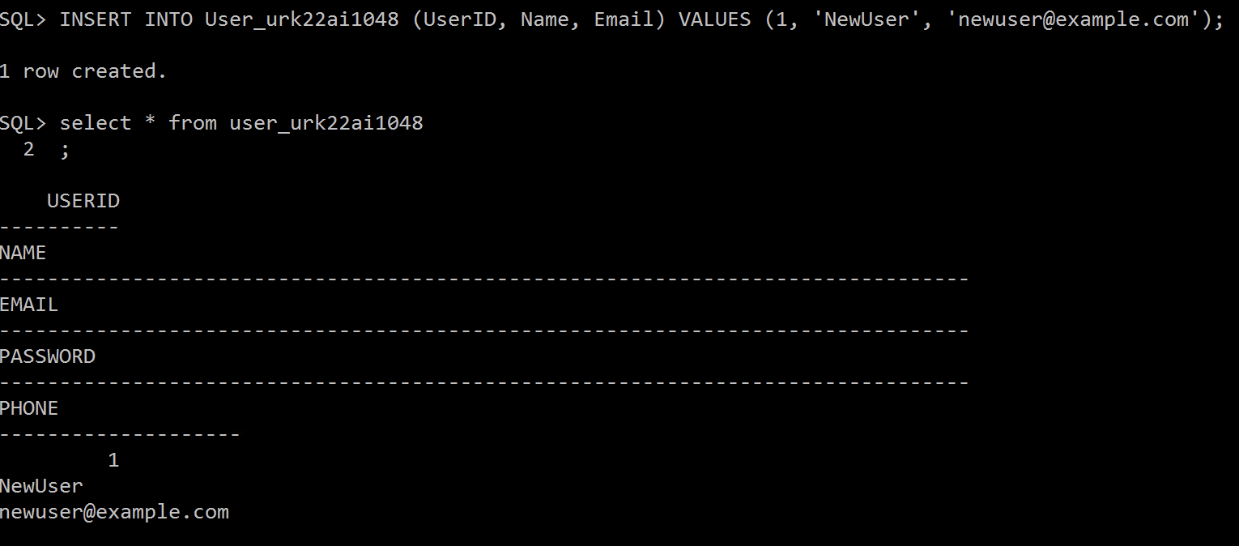

2.Update the email address of a user with UserID 1048

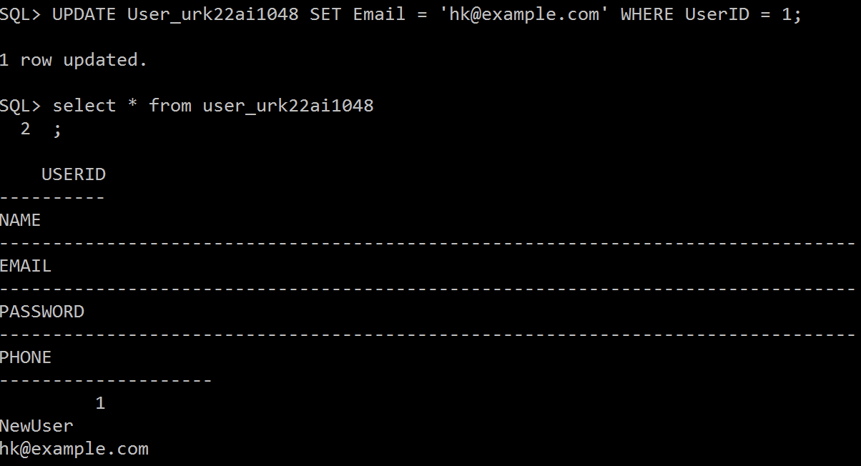

3. Delete a user with the email &quot;example@example.com.

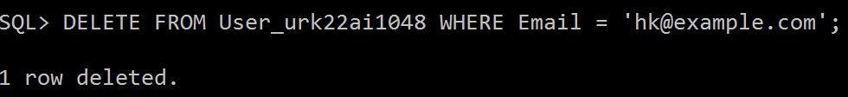

4. Insert a new event into the &quot;Event&quot; table.



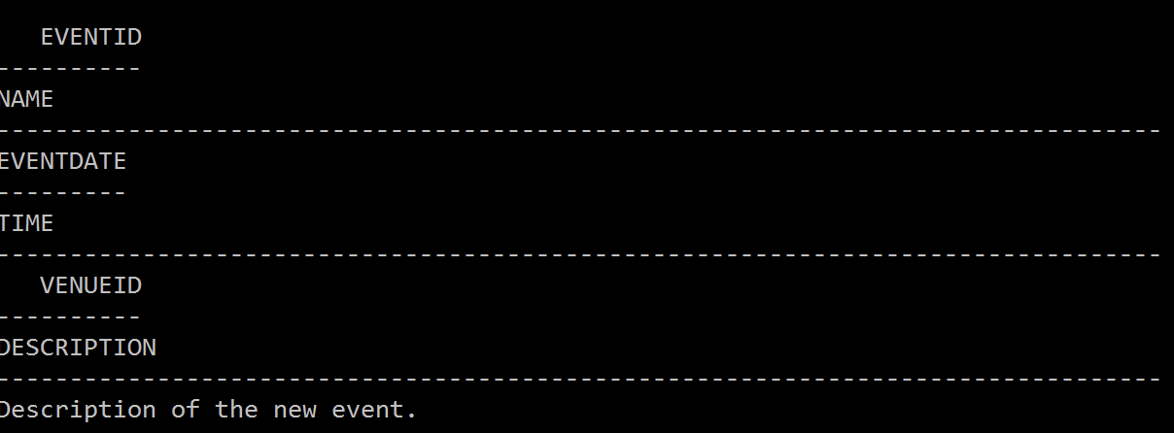

5. Update the description of an event with EventID 456.



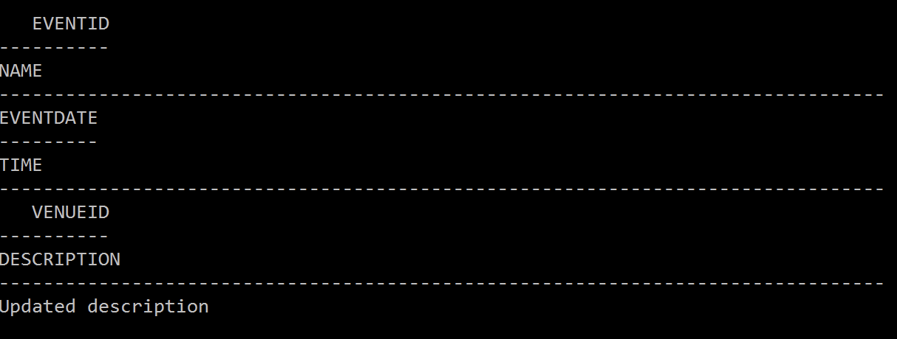

6. Grant SELECT privileges on the &quot;User&quot; table to a user named &quot;john&quot;.

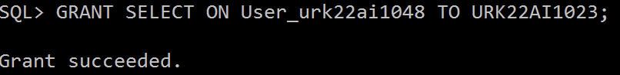

7. Revoke INSERT privileges on the &quot;Event&quot; table from a user named &quot;mary&quot;.

8. Create a new user with the username &quot;jane&quot; and grant them all privileges on the &quot;Ticket&quot; table.

9. Allow the user “Jane” to perform update operation on the “Ticket” table.

10. Perform update operation on the “Ticket&quot; table.

11. Perform commit a transaction in the database.

12. Perform roll back a transaction to a specific savepoint.

13. Perform set a savepoint within a transaction.

14. Enable autocommit mode in the database.

15. Disable autocommit mode in the database.

# RESULT:

Managing Tables using DML, DCL and TCL Commands executed successfully to create

,Insert and alter table.